ASSIGNMENT 3

//Shortest Job First (Preemptive)

#include <stdio.h>
#include <stdbool.h>

struct Process
{
int pid;
int at;
int bt;
int ct, tt, wt, rt, st;
};

int main()
{
int size = 0;
printf("Enter number of processes: ");
scanf("%d", &size);
struct Process ps[size];

printf("\nEnter process Details: \n");
for (int i = 0; i < size; ++i)
{
printf("Enter %dth process details: \n", i + 1);
ps[i].pid = i + 1;

printf("\tEnter Arrival Time: ");
scanf("%d", &ps[i].at);

printf("\tEnter Burst Time: ");
scanf("%d", &ps[i].bt);
}
int n = size;
int completed = 0;
int currentTime = 0;
int burstTimeR[4];
bool iscompleted[4] = {false};

float avgWT = 0, avgTT = 0, avgRT = 0;

for (int i = 0; i < n; i++)
{
burstTimeR[i] = ps[i].bt;
}

while (completed != n)
{

int minimum = 99999;
int miniI = -1;
for (int i = 0; i < n; i++)
{
if ((ps[i].at <= currentTime) && (iscompleted[i] == false))
{
if (burstTimeR[i] < minimum)
{
minimum = burstTimeR[i];
miniI = i;
}
if (burstTimeR[i] == minimum)
{
if (ps[i].at < ps[miniI].at)
{
minimum = burstTimeR[i];
miniI = i;
}
}
}
}

if (miniI == -1)
{
currentTime++;
}
else
{

if (burstTimeR[miniI] == ps[miniI].bt)
{
ps[miniI].st = currentTime;
}

burstTimeR[miniI] -= 1;
currentTime++;

if (burstTimeR[miniI] == 0)

{

ps[miniI].ct = currentTime;
ps[miniI].tt = ps[miniI].ct - ps[miniI].at;
ps[miniI].wt = ps[miniI].tt - ps[miniI].bt;
ps[miniI].rt = ps[miniI].st - ps[miniI].at;

avgWT += ps[miniI].wt;
avgTT += ps[miniI].tt;
avgRT += ps[miniI].rt;

completed++;
iscompleted[miniI] = true;
}
}
}
printf("\n\n====================================================================================\n");
printf("PID \t AT \t BT \t CT \t TAT \t WT \t RT \t\n");
for (int i = 0; i < n; i++)
{

printf("%d \t %d \t %d \t %d \t %d \t %d \t %d \t\n", ps[i].pid, ps[i].at, ps[i].bt, ps[i].ct, ps[i].tt, ps[i].wt, ps[i].rt);
}
printf("\n\n====================================================================================\n");

printf("\n\n AVG WT: %f", avgWT / n);
printf("\n\n AVG TAT: %f", avgTT / n);
printf("\n\n AVG RT: %f", avgRT / n);
printf("\n\n====================================================================================\n");
}

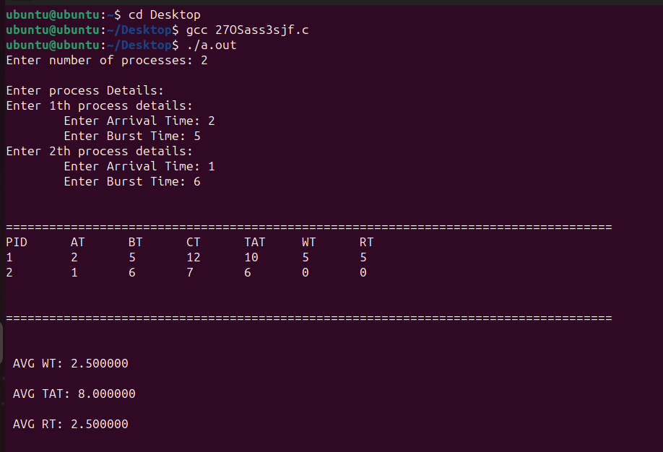

##Round Robin

#include <stdio.h>
// #include <limits.h>
#include <stdbool.h>
#include <stdlib.h> //for qsort

struct process_struct
{
int pid;
int at;
int bt;
int ct, wt, tat, rt, start_time;
int bt_remaining;
} ps[100];

int findmax(int a, int b)
{
return a > b ? a : b;
}

int comparatorAT(const void *a, const void *b)
{
int x = ((struct process_struct *)a)->at;
int y = ((struct process_struct *)b)->at;
if (x < y)
return -1;
else if (x >= y)
return 1;
}

int comparatorPID(const void *a, const void *b)
{
int x = ((struct process_struct *)a)->pid;
int y = ((struct process_struct *)b)->pid;
if (x < y)
return -1;
else if (x >= y)
return 1;
}

int main()
{

int n, index;
int cpu_utilization;
bool visited[100] = {false}, is_first_process = true;
int current_time = 0, max_completion_time;
int completed = 0, tq, total_idle_time = 0, length_cycle;
printf("Enter total number of processes: ");
scanf("%d", &n);
int queue[100], front = -1, rear = -1;
float sum_tat = 0, sum_wt = 0, sum_rt = 0;

printf("\nEnter process Details: \n");
for (int i = 0; i < n; ++i)
{
printf("Enter %dth process details: \n", i + 1);
ps[i].pid = i + 1;

printf("\tEnter Arrival Time: ");
scanf("%d", &ps[i].at);
ps[i].pid = i;

printf("\tEnter Burst Time: ");
scanf("%d", &ps[i].bt);
ps[i].bt_remaining = ps[i].bt;
}
printf("\nEnter time quanta: ");
scanf("%d", &tq);
qsort((void *)ps, n, sizeof(struct process_struct), comparatorAT);
front = rear = 0;
queue[rear] = 0;
visited[0] = true;

while (completed != n)
{
index = queue[front];
front++;

if (ps[index].bt_remaining == ps[index].bt)
{
ps[index].start_time = findmax(current_time, ps[index].at);
total_idle_time += (is_first_process == true) ? 0 : ps[index].start_time - current_time;
current_time = ps[index].start_time;
is_first_process = false;
}

if (ps[index].bt_remaining - tq > 0)
{
ps[index].bt_remaining -= tq;
current_time += tq;
}
else
{
current_time += ps[index].bt_remaining;
ps[index].bt_remaining = 0;
completed++;

ps[index].ct = current_time;
ps[index].tat = ps[index].ct - ps[index].at;
ps[index].wt = ps[index].tat - ps[index].bt;
ps[index].rt = ps[index].start_time - ps[index].at;

sum_tat += ps[index].tat;
sum_wt += ps[index].wt;
sum_rt += ps[index].rt;
}
for (int i = 1; i < n; i++)
{
if (ps[i].bt_remaining > 0 && ps[i].at <= current_time && visited[i] == false)
{
queue[++rear] = i;
visited[i] = true;
}
}
if (ps[index].bt_remaining > 0)
queue[++rear] = index;
if (front > rear)
{
for (int i = 1; i < n; i++)
{
if (ps[i].bt_remaining > 0)
{
queue[rear++] = i;
visited[i] = true;
break;
}
}
}
}
max_completion_time = 1e-9;
for (int i = 0; i < n; i++)
max_completion_time = findmax(max_completion_time, ps[i].ct);
length_cycle = max_completion_time - ps[0].at;
cpu_utilization = (float)(length_cycle - total_idle_time) / length_cycle;
qsort((void *)ps, n, sizeof(struct process_struct), comparatorPID);
printf("\n\n====================================================================================\n");
printf("\nProcess No.\tAT\tBT\tStart Time\tCT\tTAT\tWT\tRT\n");
for (int i = 0; i < n; i++)
printf("%d\t\t%d\t%d\t\t%d\t%d\t%d\t%d\t%d\n",i+1, ps[i].at, ps[i].bt, ps[i].start_time, ps[i].ct, ps[i].tat, ps[i].wt, ps[i].rt);
printf("\n");
printf("\n\n====================================================================================\n");
printf("\nAverage Turn Around time= %.2f", (float)sum_tat / n);
printf("\nAverage Waiting Time= %.2f", (float)sum_wt / n);
printf("\nAverage Response Time= %.2f\n", (float)sum_rt / n);

return 0;
}

